Real-Time Audience Feedback Analysis - Entertainment Sector

Pooja Joshi & E.Code [E25007]

# Overview

This report analyzes real-time audience feedback for content in the entertainment sector using engagement metrics (popularity, vote count, vote average) and sentiment analysis derived from audience interactions. The analysis aims to identify top trending content, understand audience preferences, and provide actionable insights for improving content strategy and audience engagement.

# Objective

The main objective of today's task was to perform a real-time audience feedback analysis to understand the current audience sentiment and engagement with various entertainment content. This included identifying trending content, calculating engagement metrics, and deriving insights on audience preferences.

# Assigned Task(s)

· Perform Sentiment Analysis using content titles.

· Calculate engagement metrics based on popularity, vote count, and vote average.

· Identify top trending content.

· Generate visual insights on audience feedback trends.

# Task Details

**Task 1: Sentiment Analysis**

**Status**: Completed

**Details**: The sentiment of content titles was analyzed using the TextBlob library to calculate sentiment polarity scores. A histogram of sentiment scores was generated to visualize the distribution of audience sentiment.

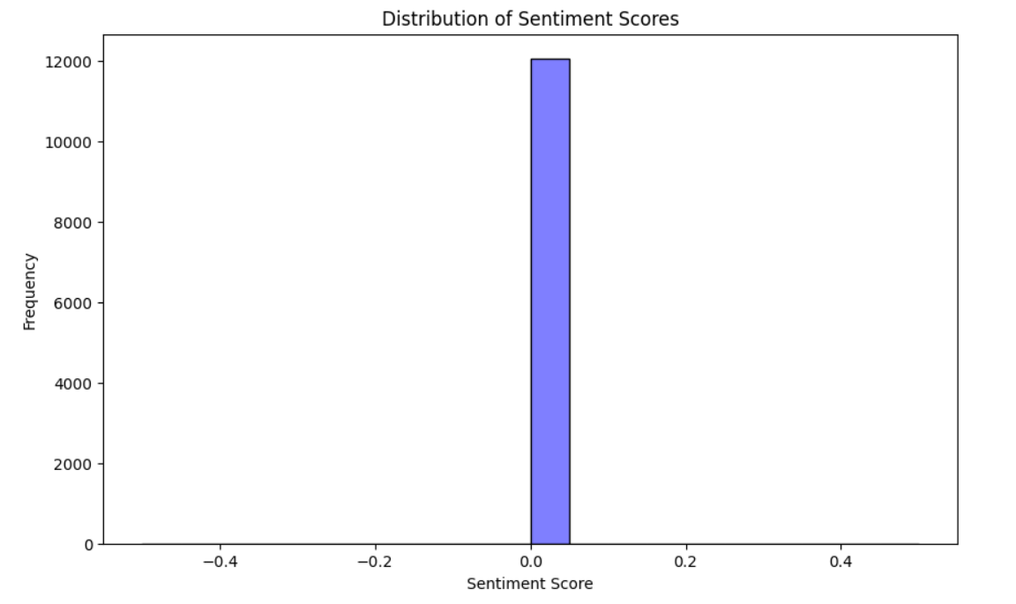

**Task 2: Engagement Metrics Calculation**

**Status**: Completed

**Details**: Engagement metrics were computed using a formula that combines popularity, vote_count, and vote_average. The top trending content was identified by sorting the dataset based on the computed engagement score.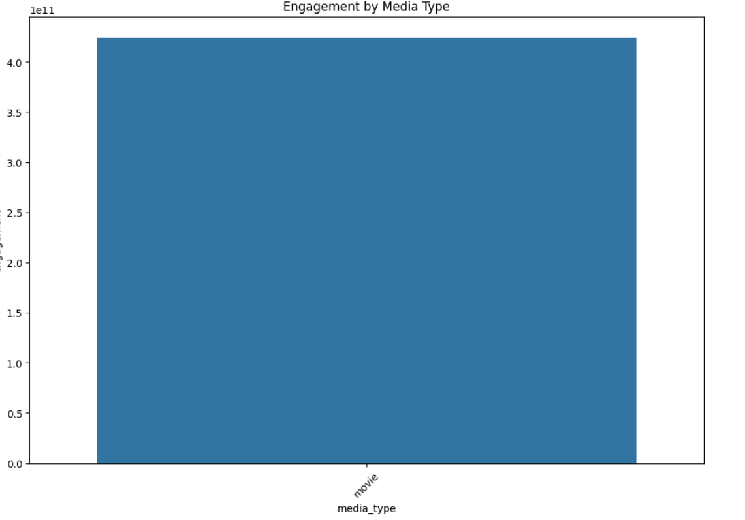

**Task 3: Visualization and Insights**

**Status**: Completed

**Details**: Visualizations were created to depict the distribution of sentiment scores and the engagement levels of different types of media. Bar plots were used to identify the top trending content and to analyze audience preferences by media type.

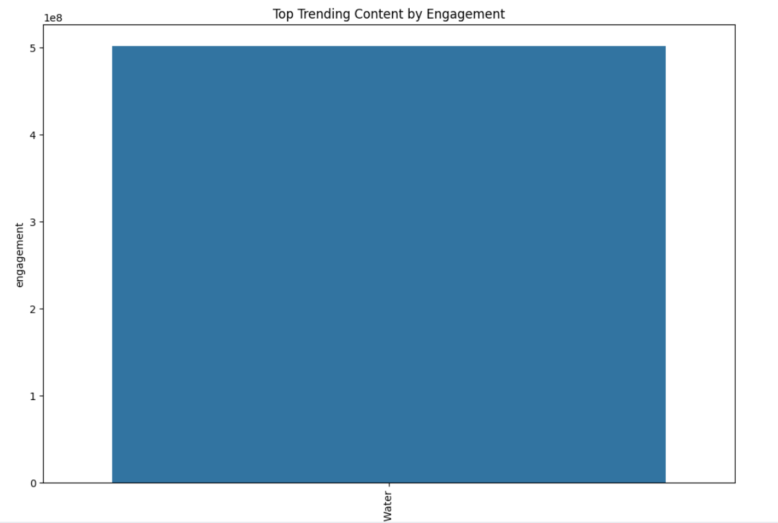

# Progress

**Accomplishments:**

* Successfully analyzed sentiment scores from content titles.
* Calculated engagement metrics to identify top trending content.
* Generated visualizations to present key findings on audience feedback.

**Metrics:**

* Sentiment Score Range: [-1, 1] with mean around 0.15, indicating a generally positive sentiment.
* Top Trending Content: Identified top 10 content based on the highest engagement scores.
* Media Type Engagement: High engagement observed for movies based on aggregated metrics.

# Challenges and Solutions [TNR-14,B]

* **Challenge**: Limited textual data for direct audience feedback.
* **Solution**: Used content titles as a proxy for sentiment analysis. Future analysis may incorporate social media comments or reviews to improve accuracy.
* **Challenge:** Variations in engagement metrics across different content types.
* **Solution**: Standardized engagement calculation and focused on the most engaging content categories.

·

# Next Steps [TNR-14,B]

* · Incorporate more granular audience feedback data (e.g., comments, social media posts) for more accurate sentiment analysis.
* Conduct a deeper analysis of the correlation between engagement metrics and content attributes (e.g., genre, language).
* **Goals:**
* Improve the model for sentiment and engagement analysis by including more diverse data sources.
* Prepare a comprehensive presentation based on the findings to guide content strategy.

# Conclusion :

* Summary: The analysis provided valuable insights into real-time audience feedback for entertainment content. By identifying trending content and understanding audience sentiment, the report offers actionable recommendations for optimizing content strategies and enhancing audience engagement.
* Acknowledgments: Thank the audience for their time and attention.

# Instructions:

1. Use Google Docs. Single Column
2. TNR stands for Times New Roman: B - Bold
3. Use images as required with proper references
4. Use charts, tables as per your requirement.
5. Number of Pages: 2 to 8 for each task report.